|  |  |  |  |  |  |  |  |  |  |  |  |  |  |  |  |  |  |  |  |  |  |  |  |  |  |  |  |  |
| --- | --- | --- | --- | --- | --- | --- | --- | --- | --- | --- | --- | --- | --- | --- | --- | --- | --- | --- | --- | --- | --- | --- | --- | --- | --- | --- | --- | --- |
| |  | | --- | | **20/09/24** | | **September 2024** | |  | | **October 2024** | | Poetry Day Assembly– **Thursday 3rd October** | | Hello Yellow Day – **Thursday October 10th** (Non-uniform – include something yellow!) | | Family Attendance Meetings- **Thursday 17th October** | | Half term holiday **28 October – 1 November** | | Year Four Harvest Festival – Y4 Families invited – **Tuesday 22nd October at 2:45pm** | | **November 2024** | | School closed for staff training – **Monday 4th November** | | Remembrance Day – **Monday 11th November** (special assembly in school) | | Odd Socks Day – 12th November – Wear Odd Socks for School | | Parent/ Carer Consultation for Reception and Y1 and Y2 - **Wednesday 13th November** | | Children in Need Day – Non-uniform for a donation – **Friday 15th November** | | Parents evening for Y3, Y4, Y5 and Y6 – **Wednesday 20th November** | | Christmas holidays – break up 20th December and return to school 6th January | | **December 2024** | | Christmas Jumper Day (wear your Christmas jumper to school) – **Thursday 12th December** | | Christmas Party Day (children to come to school in party clothes) – **Tuesday 17th December** | | Year 3 and Year 4 (Year 3 lead performance) – Carols at St. John’s – **Thursday 19th December at 2:30pm (parents invited) TBC** | | Year 5 and Year 6 (Year 5 lead performance) – Carols at St. John’s – **Friday 20th December at 2:30pm (parents invited) TBC** | | **Nursery and reception and KS1 Christmas performance dates will be set soon.** | | **January 2025** | | **Panto for pupils – Monday 6th January** | | **French Day – Tuesday 21st January** | |  | |  |
| |  | | --- | | **February 2025** | | Valentine’s Disco –Reception – **Monday 10th February at 2:15pm** | | Safer Internet Day – **Tuesday 11th February (Assembly in school for children)** | | Valentine’s Disco – Year One and Two – **Tuesday 11th February 3:30 – 4:30pm** | | Valentine’s Disco – Year Three and Year Four – **Wednesday 12th February 3:30pm – 4:30pm** | | Valentine’s Disco – Year Five and Year Six – **Thursday 13th February 3:30pm – 4:30pm** | | Half term holiday – break up on **Friday 21st February and return to school on Monday 3rd March** | | March 2025 | | World Book Day – **Thursday 6th March – more information to follow.** | | Red Nose Day – **Non-uniform – Friday 14th March** | | **April 2025** | | Family Attendance Meetings **– Wednesday 2nd April** | | Faith Day **– Friday 11th April (parents will be invited into school from 2:45pm to look at children’s work on different faiths)** | | Break up for the Easter holidays on Friday 11th April and return to school on **Monday 28th April** | | **May 2025** | | Earth Day-non-uniform day (wear something green) – **Friday 2nd May** | | BANK HOLIDAY – School Closed – **Monday 5th May** | | Year 6 SATs week – Monday 12th May – **Thursday 15th May** | | Family attendance meetings – **Wednesday 21st May** | | Break up for half term holiday on **Friday 23rd May and return to school on Monday 2nd June** | | **June 2025** | | Year Four Multiplication Check **– Week beginning 2nd June** | | Nursery and Reception Sports Day – **Tuesday 3rd June at 2:15pm** | | Year One and Year Two Sports Day – **Wednesday 4th June at 2:15pm** | | Year Three and Year Four Sports Day – **Thursday 5th June at 2:15pm** | | Year Five and Year Six Sports Day – **Friday 6th June at 2:15pm** | | Year One Phonics Screening – **Week Beginning Monday 9th June** | | Occasional Day – School Closed – **Friday 13th June** | | Rainbow Day- Non-uniform and assembly in school – **Friday 20th June** | | Glynwood Arts, Music and Craft Festival – 23rd June – **Friday 4th July** | | **July 2025** | | Glynwood Art Exhibition **– open to families from 3:15 – 3:45 on Wednesday 2nd July, Thursday 3rd July and Friday 4th July.** | | Family attendance meetings – **Tuesday 8th July** | | Pupil end of year reports out to families – **Friday 11th July** | | Last Day of term for the summer break – **Friday 18th July** | |  |

**Message from Mrs. Nellis:**

Health and Safety - We understand that many parents/ carers come into the school car park to drop off/ pick up when children are going to breakfast club and afterschool club. When on the school site please remember to keep your speed low when entering and exiting.

Mobile Phones - As usual at this time of year we see an increase in the number of children bringing mobile phones into school. Mobiles are locked in the cabinet in main reception during the school day, and should not be brought in unless absolutely necessary.

Fundraising with Asda (please see attached flyer) - Do you shop with Asda? You can use the rewards app to donate to our school funds, it doesn’t cost you anything, but we will receive £1 when you choose our school on the app, then 0.5% of the value of your shop between now and 30th November 2024.

No Cold Child – this year, fashion brand Fatface and The Guiness Partnership have partnered with Parentkind, an organization for school PTA’s to provide winter coats for children at a cost of £10 each. (£60rrp). We would like you to be able to take advantage of this offer – we have set up a payment item in the shop on Parentmail for you to order. Unfortunately, we cannot control the number of coats available, but please be assured that if supply is restricted you will receive a full refund. In order to take advantage of this offer please place your order by the end of next week. If for any reason you require additional time, please speak to a member of the school office staff.

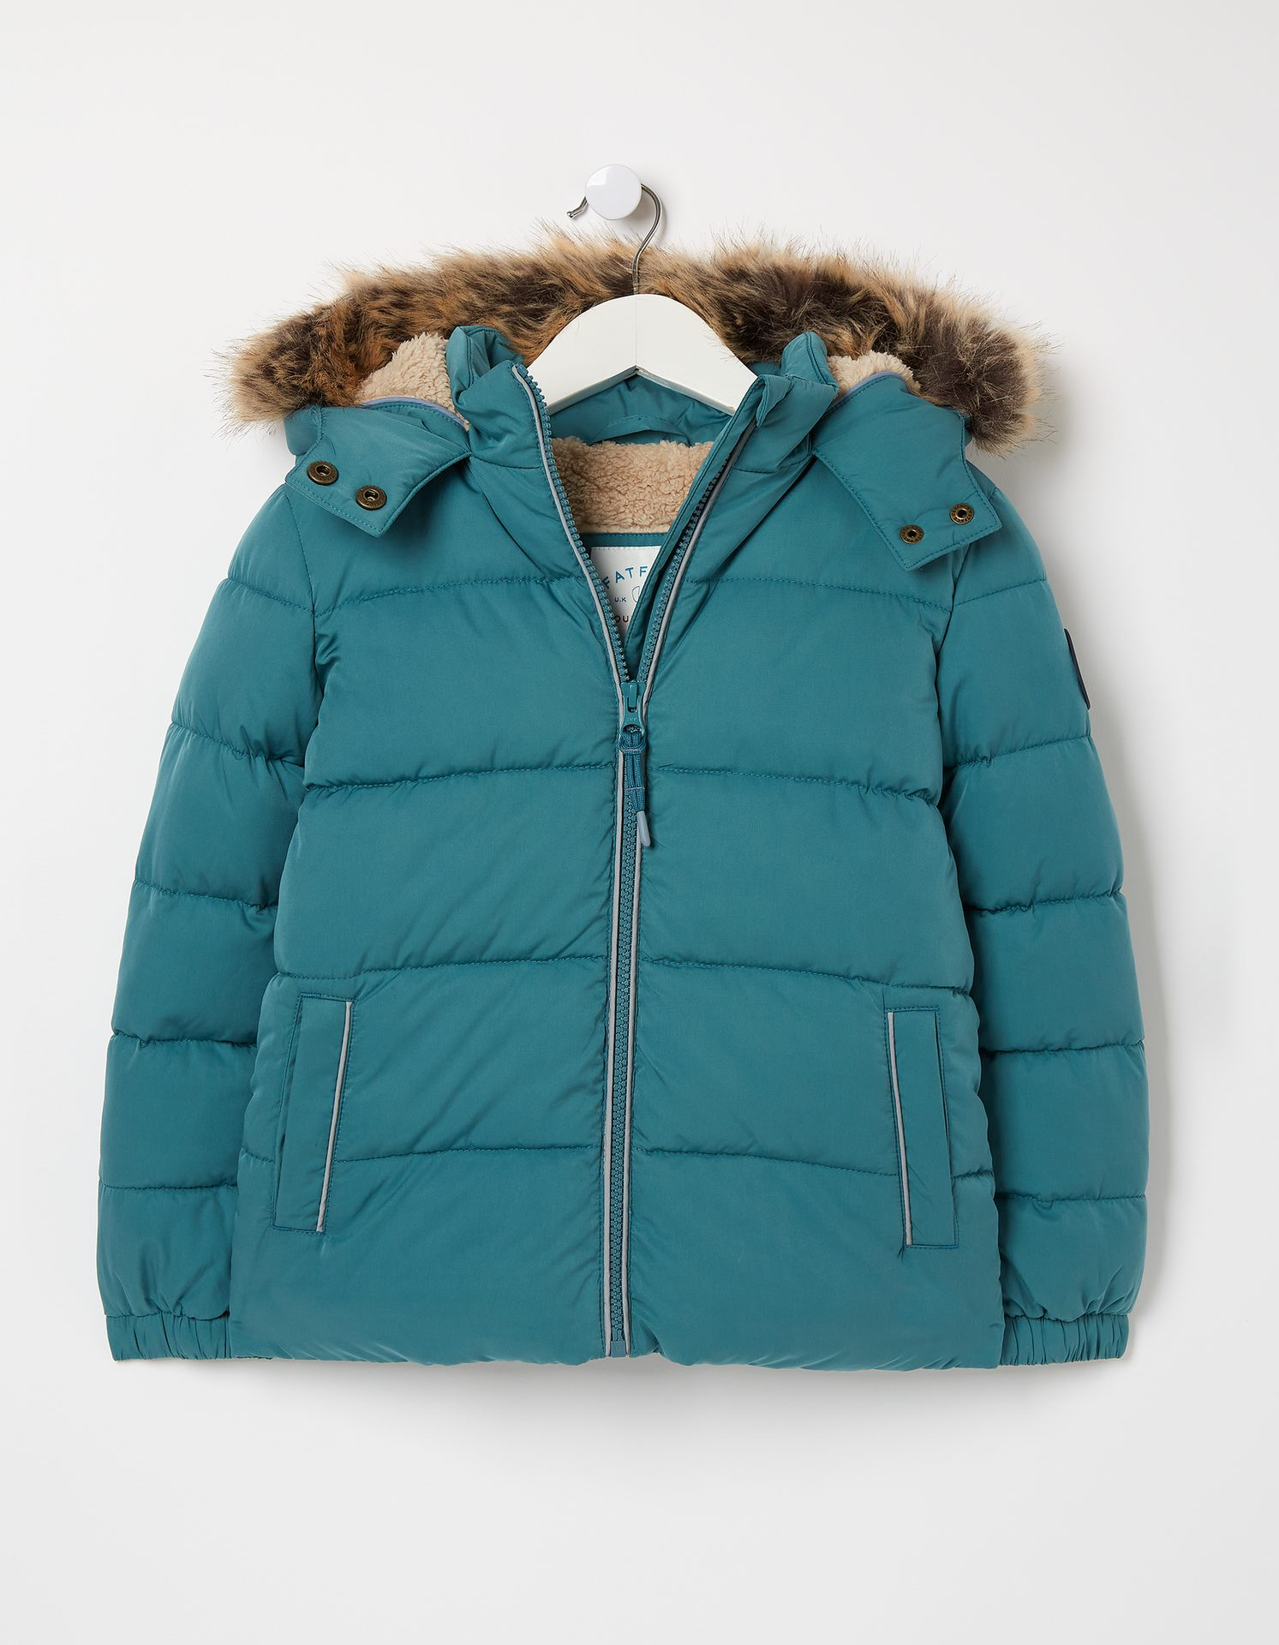 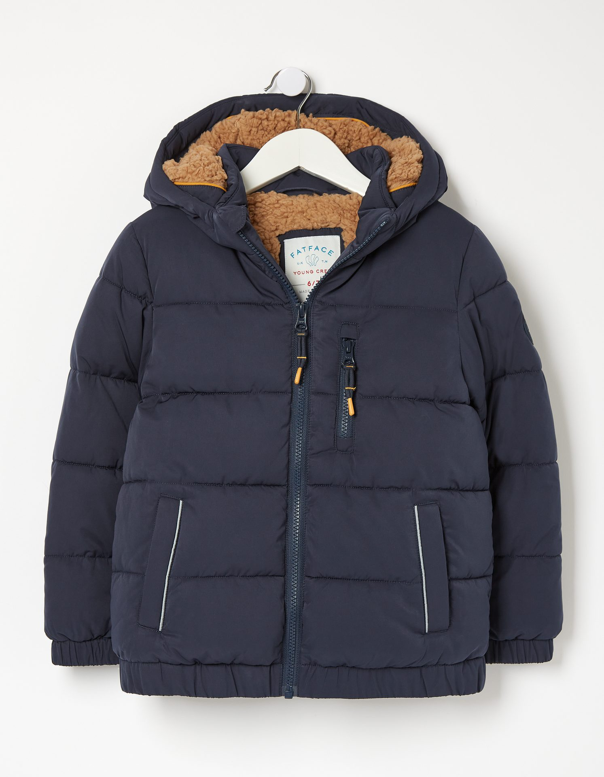

**Child Protection and Safeguarding**

Child Protection and Safeguarding are always an absolute priority in school. Our designated safeguarding leads and deputies are: Vicky Nellis (Head Teacher), Carolyn Dobbing (Home School Liaison Officer), Simon Otterson (Deputy Head), Sarah Brunskill (Assistant Head), Esther Commons (SENDco) and Jude Etherington (Curriculum leader). Please talk to any of us about any concerns that you may have. Posters displaying photos of the designated safeguarding leads are displayed around school.

If you have concerns about a child in your community, you have a number of options:

1. You can call 101 and ask for some welfare advice. This can be done anonymously.
2. You can visit the NSPCC website on: <https://www.nspcc.org.uk/keeping-children-safe/reporting-abuse/report/> or you can call the NSPCC helpline on 0808 800 5000, You can report concerns here anonymously too.

Chimney Sweep Club: Spaces are still available. This is the link to apply

<https://chimneysweeptc.co.uk/product/glynwood-community-primary-school-autumn-1st-half-term-2024-y4-y6/>

**Free School Meals** – Our school can access additional funding from the government for those children entitled to means tested free school meals? This is called Pupil Premium. We will use Pupil Premium to support a range of strategies, both whole school and those which target individual children, to ensure every child has the opportunity to reach their potential. Pupil Premium is also used to offer children experiences and support their cultural and personal development, through for example, Forest School, residential visits and pantomime/theatre visits. The funding is also used to employ our Home/School Liaison Officer who focuses on the wellbeing of all of our children.

We would like to encourage any of you who think you may be entitled to apply. The easiest way to apply is by visiting

<https://www.gateshead.gov.uk/article/7433/Free-school-meals> and click on 'Apply For Free School Meals'

Alternatively, you can apply by telephone on 0191 433 3429.

Thank you again for your continued support.

With my best wishes

Vicky Nellis   
Head Teacher